实验（9）—— 运算符重载

学生姓名：黄伟杰 专业班级：计算机211
课程名称：面向对象程序设计 实验类型：综合

一 实验目的
练习C++运算符重载。

二 实验环境
PC机 + Windows 10操作系统 + CodeBlocks 集成开发环境

三 实验内容
编写一个MyInt类，内有1个私有数据成员为int x，请在该类中设计如下重载运算符函数。
operator==
operator+
operator=
operator++
#include <iostream>
using namespace std;
class MyInt {
private:
int x;
public:
MyInt(int _x = 0) : x(_x) {}
void Disp() {
cout << "X = " << x << '\n';
}
bool operator== (int t) {
if (x == t) return true;
else return false;
}
MyInt operator+ (int t) {
return MyInt(x + t);
}
MyInt operator+ (MyInt t) {
return MyInt(x + t.x);
}
MyInt& operator= (int t) {
x += t;
return *this;
}
MyInt& operator++ () {
x ++;
return *this;
}
MyInt operator++ (int) {
MyInt old = *this;
++(*this);
return old;
}
};
int main() {
MyInt t1_1(1), t1_2;
if (t1_1 == 1) cout << "True" << '\n';
else cout << "False" << '\n';
t1_2 = t1_1 + 1; t1_2.Disp();
++t1_1; t1_1.Disp();
t1_1++; t1_1.Disp();

MyInt t2_1(1), t2_2;
if (t2_1 == 2) cout << "True" << '\n';
else cout << "False" << '\n';
t2_2 = t2_1 + t2_1; t2_2.Disp();
++t2_1; t2_1.Disp();
t2_1++; t2_1.Disp();

MyInt t3_1(5), t3_2;
if (t3_1 == 5) cout << "True" << '\n';
else cout << "False" << '\n';
t3_2 = t3_1 + 5; t3_2.Disp();
++t3_1; t3_1.Disp();
t3_1++; t3_1.Disp();

return 0;
}
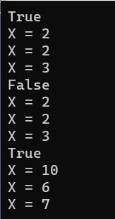
编写一个MyArray类，内有1个私有数据成员为int x[N]，请在该类中设计如下重载运算符函数。
operator==
operator+
operator=
operator++
operator[]
#include <iostream>
using namespace std;
const int N = 10;
class MyArray {
private:
int x[N];
public:
MyArray(int *_x){
for (int i = 0; i < N; i ++) x[i] = _x[i];
}
void Disp() {
for (int i = 0; i < N; i ++) cout << x[i] << " ";
cout << '\n';
}
bool operator== (int *t) {
for (int i = 0; i < N; i ++)
if (x[i] != t[i]) return false;
return true;
}
MyArray& operator+ (int t) {
for (int i = 0; i < N; i ++) x[i] += t;
return *this;
}
MyArray& operator= (int *t) {
for (int i = 0; i < N; i ++) x[i] = t[i];
return *this;
}
MyArray& operator++ () {
for (int i = 0; i < N; i ++) x[i] ++;
return *this;
}
MyArray operator++ (int) {
MyArray old = *this;
++(*this);
return old;
}
int& operator[] (int idx) {
return x[idx];
}
};
int main() {
int arr1[N] = {0, 1, 2, 3, 4, 5, 6, 7, 8, 9};
MyArray t1(arr1);
if (t1 == arr1) cout << "True" << '\n';
else cout << "False" << '\n';
t1 = t1 + 5; t1.Disp();
++ t1; t1.Disp();
t1[0] = 1; t1.Disp();

int arr2[N] = {6, 5, 1, 32, 48, 9, 6, 1, 6, 32};
MyArray t2(arr2);
if (t2 == arr2) cout << "True" << '\n';
else cout << "False" << '\n';
t2 = t2 + 10; t2.Disp();
++ t2; t2.Disp();
t2[0] = 5; t2.Disp();

int arr3[N] = {9, 8, 74, 6, 51, 32, 12, 36, 5, 4};
MyArray t3(arr3);
if (t3 == arr3) cout << "True" << '\n';
else cout << "False" << '\n';
t3 = t3 + 1; t3.Disp();
++ t3; t3.Disp();
t3[0] = 10; t3.Disp();

return 0;
}
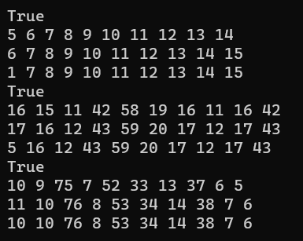
编写一个MyMatrix类，内有1个私有数据成员为int x[M][N]，请在该类中设计如下重载运算符函数。
operator!=
operator-
operator=
operator--
#include <iostream>
using namespace std;
const int M = 2, N = 3;
class MyMatrix {
private:
int x[M][N];
public:
MyMatrix(int _x[M][N]) {
for (int i = 0; i < M; i ++)
for (int j = 0; j < N; j ++)
x[i][j] = _x[i][j];
}
void Disp() {
for (int i = 0; i < M; i ++) {
for (int j = 0; j < N; j ++)
cout << x[i][j] << " ";
cout << '\n';
}
}
bool operator!= (int t[M][N]) {
for (int i = 0; i < M; i ++)
for (int j = 0; j < N; j ++)
if (x[i][j] != t[i][j]) return false;
return true;
}
MyMatrix& operator- (int t) {
for (int i = 0; i < M; i ++)
for (int j = 0; j < N; j ++)
x[i][j] -= t;
return *this;
}
MyMatrix& operator= (int t[M][N]) {
for (int i = 0; i < M; i ++)
for (int j = 0; j < N; j ++)
x[i][j] = t[i][j];
return *this;
}
MyMatrix& operator-- () {
for (int i = 0; i < M; i ++)
for (int j = 0; j < N; j ++)
x[i][j] --;
return *this;
}
MyMatrix operator-- (int) {
MyMatrix old = *this;
--(*this);
return old;
}
};
int main() {
int arr1[M][N] = {{0, 1, 2}, {3, 4, 5}};
MyMatrix t1(arr1);
if (t1 != arr1) cout << "False" << '\n';
else cout << "True" << '\n';
t1 = t1 - 1; t1.Disp();
-- t1; t1.Disp();

int arr2[M][N] = {{50, 14, 72}, {31, 48, 57}};
MyMatrix t2(arr2);
if (t2 != arr2) cout << "False" << '\n';
else cout << "True" << '\n';
t2 = t2 - 5; t2.Disp();
-- t2; t2.Disp();

int arr3[M][N] = {{22, 11, 27}, {73, 46, 53}};
MyMatrix t3(arr3);
if (t3 != arr3) cout << "False" << '\n';
else cout << "True" << '\n';
t3 = t3 - 12; t3.Disp();
-- t3; t3.Disp();

return 0;
}
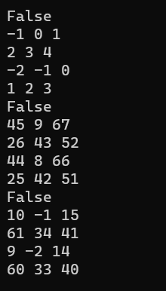
设计一个三角形类Triangle，包含三角形三条边长的私有数据成员，另有一个重载运算符“+”，以实现求两个三角形对象的面积之和。并能计算任意多个三角形的面积之和。
#include <iostream>
#include <cmath>
using namespace std;
class Triangle {
private:
double x, y, z;
double area;
public:
Triangle(int _x, int _y, int _z) : x(_x), y(_y), z(_z) {
double p = (x + y + z) / 2.0;
area = sqrt(p * (p - x) * (p - y) * (p - z));
}
double operator+ (Triangle t) {
double square = area + t.area;
return square;
}
friend double operator+ (double now, Triangle t) {
return now + t.area;
}
};
int main() {
Triangle t1_1(3, 4, 5);
cout << t1_1 + t1_1 << '\n';

Triangle t2_1(3, 4, 5), t2_2(2, 2, 2);
cout << t2_1 + t2_2 << '\n';

Triangle t3_1(3, 4, 5);
cout << t3_1 + t3_1 + t3_1 << '\n';

return 0;
}
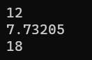
设计一个书本类，内有书名，作者，出版社，价格等信息。重载=，==（判断两本书是否一样），++（书本的价格加1元），<<（打印书本信息）
#include <iostream>
#include <string>
#include <fstream>
using namespace std;
class Book {
private:
string name, author, pub;
double price;
public:
Book() {}
Book(string _name, string _author, string _pub, double _price) {
name = _name;
author = _author;
pub = _pub;
price = _price;
}
Book& operator= (Book t) {
name = t.name;
author = t.author;
pub = t.pub;
price = t.price;
return *this;
}
bool operator== (Book t) {
if (name == t.name && author == t.author && pub == t.pub && price == t.price) return true;
return false;
}
Book& operator++ () {
price ++;
return *this;
}
Book operator++ (int) {
Book old = *this;
++(*this);
return old;
}
friend ostream& operator<< (ostream& os, Book& t) {
os << t.name << '\n';
os << t.author << '\n';
os << t.pub << '\n';
os << t.price << '\n';
return os;
}
};
int main() {
double t1_price = 10;
string t1_name = "一本书", t1_author = "一个作者", t1_pub = "一个出版社";
Book t1_1, t1_2(t1_name, t1_author, t1_pub, t1_price);
t1_1 = t1_2;
cout << t1_1;
if (t1_1 == t1_2) cout << "True" << '\n';
else cout << "False" << '\n';
t1_1 ++; cout << t1_1;

double t2_price = 20;
string t2_name = "一本书", t2_author = "一个作者", t2_pub = "一个出版社";
Book t2_1, t2_2(t2_name, t2_author, t2_pub, t2_price);
t2_1 = t2_2;
cout << t2_1;
if (t2_1 == t2_2) cout << "True" << '\n';
else cout << "False" << '\n';
t2_1 ++; cout << t2_1;

double t3_price = 30;
string t3_name = "一本书", t3_author = "一个作者", t3_pub = "一个出版社";
Book t3_1, t3_2(t3_name, t3_author, t3_pub, t3_price);
t3_1 = t3_2;
cout << t3_1;
if (t3_1 == t3_2) cout << "True" << '\n';
else cout << "False" << '\n';
t3_1 ++; cout << t3_1;

return 0;
}
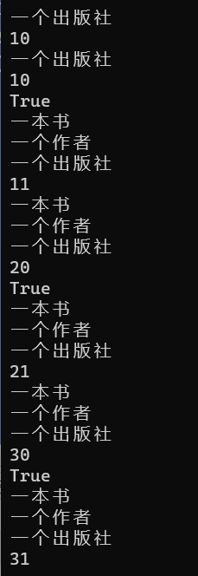
设计一个点类Point，实现点对象之间的各种运算。
= + == += 前置++ 后置++ <<
#include <iostream>
#include <string>
#include <fstream>
using namespace std;
class Point {
private:
int x, y;
public:
Point(int _x = 0, int _y = 0) : x(_x), y(_y) {}
Point& operator= (Point t) {
x = t.x;
y = t.y;
return *this;
}
Point operator+ (Point t) {
return Point(x + t.x, y + t.y);
}
bool operator== (Point t) {
if (x == t.x && y == t.y) return true;
return false;
}
void operator+= (Point t) {
x += t.x;
y += t.y;
}
Point& operator++ () {
x ++;
y ++;
return *this;
}
Point operator++ (int) {
Point old = *this;
++(*this);
return old;
}
friend ostream& operator<< (ostream& os, Point& t) {
os << t.x << " " << t.y << '\n';
return os;
}
};
int main() {
Point t1_1(1, 2), t1_2(3, 4);
cout << t1_1 << t1_2;
t1_1 = t1_2; cout << t1_1;
t1_1 = t1_1 + 5; cout << t1_1;
t1_1 += t1_2; cout << t1_1;
t1_1 ++; cout << t1_1;

Point t2_1(11, 2), t2_2(33, 4);
cout << t2_1 << t2_2;
t2_1 = t2_2; cout << t2_1;
t2_1 = t2_1 + 1; cout << t2_1;
t2_1 += t2_2; cout << t2_1;
t2_1 ++; cout << t2_1;

Point t3_1(12, 23), t3_2(34, 45);
cout << t3_1 << t3_2;
t3_1 = t3_2; cout << t3_1;
t3_1 = t3_1 + 10; cout << t3_1;
t3_1 += t3_2; cout << t3_1;
t3_1 ++; cout << t3_1;

return 0;
}
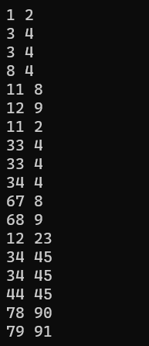
编写一个类似string类的String类,类的声明如下：
class String
{
public:
// 构造函数的重载
String( const char * = 0 );
String( const String & );
// 析构函数
~String();
// 赋值操作符+的重载
String operator+( const String & );
String operator+( const char * );
// 赋值操作符=的重载
String& operator=( const String & );
String& operator=( const char * );
// 重载的下标[]操作符
char& operator[]( int ) const;
// 等于操作符==的重载集合
bool operator==( const char * ) const;
bool operator==( const String & ) const;
// 重载<< ，>>
friend ostream& operator<<( ostream &, const String & );
friend istream& operator>>( istream &is, String &s);
// 接口
int size() { return _size; }
char* c_str() { return _string; }
private:
int _size;
char *_string;
};
#include <iostream>
#include <cstring>
#include <fstream>
using namespace std;
class String {
public:
// 构造函数的重载
String(const char* = 0) {
_size = 0;
_string = NULL;
}
String(const String& t) {
_size = t._size;
_string = new char[_size + 1];
}
// 析构函数
~String() {

}
// 赋值操作符+的重载
String operator+ (const String& t) {
String tmp;
tmp._size = _size + t._size;
tmp._string = new char[tmp._size + 1];
strcpy(tmp._string, _string);
strcat(tmp._string, t._string);
return tmp;
}
String operator+ (const char *t) {
String tmp;
tmp._size = _size + strlen(t);
tmp._string = new char[tmp._size + 1];
strcpy(tmp._string, _string);
strcat(tmp._string, t);
return tmp;
}
// 赋值操作符=的重载
String& operator= ( const String& t) {
delete[] _string;
_size = t._size;
_string = new char[_size + 1];
strcpy(_string, t._string);
return *this;
}
String& operator= ( const char *t) {
delete[] _string;
_size = strlen(t);
_string = new char[_size + 1];
strcpy(_string, t);
return *this;
}
// 重载的下标[]操作符
char& operator[] (int idx) const {
return _string[idx];
}
// 等于操作符==的重载集合
bool operator== (const char *t) const {
if (!strcmp(_string, t)) return true;
else return false;
}
bool operator== (const String& t) const {
if (!strcmp(_string, t._string)) return true;
else return false;
}
// 重载<< ，>>
friend ostream& operator<< (ostream& os, const String& t) {
os << t._string;
return os;
}
friend istream& operator>> (istream& is, String& t) {
is >> t._string;
return is;
}
// 接口
int size() {
return _size;
}
char* c_str() {
return _string;
}
private:
int _size;
char *_string;
};
int main() {
char t1_char[10] = "ABCDEF";
String t1_1, t1_2;
t1_2 = "abcd";
t1_1 = t1_2;
cout << t1_1 << '\n';
t1_1 = t1_1 + t1_2;
cout << t1_1 << '\n';
t1_2 = t1_2 + t1_char;
cout << t1_2 << '\n';
t1_2[0] = 'A';
cout << t1_2 << '\n';
if (t1_1 == t1_2) cout << "True" << '\n';
else cout << "False" << '\n';
if (t1_1 == t1_char) cout << "True" << '\n';
else cout << "False" << '\n';

char t2_char[10] = "awdasd";
String t2_1, t2_2;
t2_2 = "xxxxx";
t2_1 = t2_2;
cout << t2_1 << '\n';
t2_1 = t2_1 + t2_2;
cout << t2_1 << '\n';
t2_2 = t2_2 + t2_char;
cout << t2_2 << '\n';
t2_2[7] = 'b';
cout << t2_2 << '\n';
if (t2_1 == t2_2) cout << "True" << '\n';
else cout << "False" << '\n';
if (t2_1 == t2_char) cout << "True" << '\n';
else cout << "False" << '\n';

char t3_char[10] = "dwaawd";
String t3_1, t3_2;
t3_2 = "asdda";
t3_1 = t3_2;
cout << t3_1 << '\n';
t3_1 = t3_1 + t3_2;
cout << t3_1 << '\n';
t3_2 = t3_2 + t3_char;
cout << t3_2 << '\n';
t3_2[2] = 'x';
cout << t3_2 << '\n';
if (t3_1 == t3_2) cout << "True" << '\n';
else cout << "False" << '\n';
if (t3_1 == t3_char) cout << "True" << '\n';
else cout << "False" << '\n';

return 0;
}
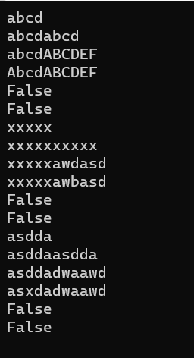
四 实验小结
巩固了C++的运算符重载。

